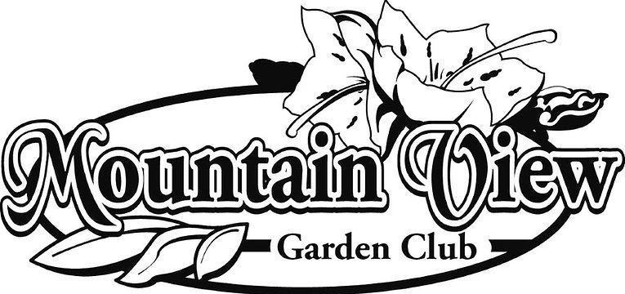

2025 -2026 EDUCATIONAL GRANT FINAL REPORT
Due by July 15, 2026 to MountainViewGC2005@Gmail.com
PROJECT TITLE____________________________________________________________________
APPLICANT’S NAME ________________________________________________________________
GRADE & SUBJECT _________________________________________________________________
SCHOOL DISTRICT __________________________________________________________________
ACTIVITY TIMELINE: BEGIN DATE___________________ END DATE __________________________
TOTAL # OF STUDENTS IMPACTED: _________________________________________________________
TOTAL FINAL COST: _________________________________________________________________
On a separate document, please provide a review of the project:
- What was the best success factor of the project?
- What are the top 3 observations learned by the students?
- Were there any challenges or unforeseen issues that arose?
- How do you see this benefitting the students' education, community involvement, and future interest in ecology?
- Would you recommend this grant to other teachers?
- How can MVGC improve the grant program?
- Please attach your evaluation resources described on question 6 in your application, if any. Ex: photos, student reports, etc. (Describe how the project will be evaluated?)
- Have you given funding credit to MVGC in any publicity or project signage?
- Please attach a copy of all receipts.
Signature of Recipient: _______________________________ Date: ____________
Signature of Principle: _______________________________ Date: ____________

